Name____________________________________________ Class 80______ Date ___________
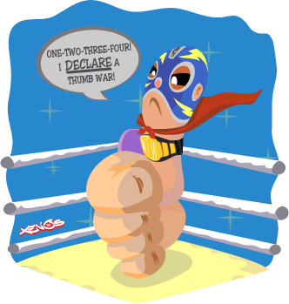
Background: In order to learn information about our world, we create testable hypotheses based on our observations. In this lab activity, you will be looking to discover a relationship between thumb length and thumb wrestling skills using the nature of science skills we have been learning about in class.

Question:
Who is the thumb wrestling champion?

Hypothesis:
Write a hypothesis using our “If…, then … because…” format to determine what type of thumb will be the champ.

Data:
What type of data will you be using in this activity?

Procedure:
Use a ruler to measure the length of your thumb in centimeters. Collect the data for thumb length for all the members of your group. The length of each thumb should be reported to at least one decimal place. Be sure to share your individual thumb length from your group with the class data.
Team Member Name | Thumb Length (cm)
1.
2.
3.
4.
5.
According to the World Federation of Thumb Wrestling (WFTB), to properly thumb wrestle an opponent, you must hook four fingers of the right hand to four fingers of the opponent’s hand and clasp firmly. To begin the match, both players must say, “one, two, three, four, I declare a thumb war,” while alternating tapping both side of the map (hands). Once the match begins, both players need to try and trap, pin, or capture their opponent’s thumb for five (5) seconds. Players may ONLY use their thumb to capture their opponent’s thumb; no other hands or fingers can get involved. Your arms must remain on the table while thumb wrestling. Good luck!
Data Collection:
Complete the chart below of the results of your thumb wars using the WFTB guidelines.
Match: Player # vs. Player # | Results: Trial 1(Who Won?) | Results: Trial 2 (Who Won?)
1 vs 2
1 vs 3
1 vs 4
1 vs 5
2 vs 3
2 vs 4
2 vs 5
3 vs 4
3 vs 5
4 vs 5

Team Member Name | Total Wins
1.
2.
3.
4.
5.
In the chart below, record the class data from the overhead. This data represents the number of thumbs that fall into a specific length compared to the number of wins that thumb length had in the class tournament.

Thumb
Length
Wins
Length | < 4.9 | 5.0, 5.1 | 5.2, 5.3 | 5.4, 5.5 | 5.6, 5.7 | 5.8, 5.9 | 6.0, 6.1 | 6.2, 6.3 | 6.4, 6.5 | 6.6, 6.7 | 6.8, 6.9 | 7.0, 7.1 | 7.2, 7.3 | 7.4, 7.5 | 7.6, 7.7 | 7.8, 7.9 | 8.0 >

What trends do you notice in the class data?

Analysis and Conclusions:
Answer the following sentences using complete sentences. Be sure to reference the data you collected in class to support your opinions.
- What was the independent variable in the experiment? What was the dependent variable in the experiment?

- In your group, who won the most rounds of thumb wars? Identify a significant piece of data regarding their thumb (shortest, longest, etc.).

- Do you believe the data collected was accurate? Why or why not?

- What are some other variables that we could have addressed in our experiment?

- Does thumb length help in winning thumb wars? Defend your answer using the class data.

